**Did you remember to empty your pockets, before placing items in the soiled linen hamper?**

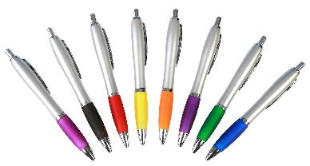Just one pen can ruin an entire load of scrubs with ink stains. One load contains approximately 500 pieces at a value of $3000. HCSA processes an estimated $70,000 worth of scrubs daily.

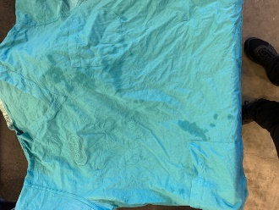

Some medicines, chemicals, stickers and EKG leads leave a residue as well, please be careful and keep these items out of the laundry, which can also be hazardous to staff.